Retail Customer Retention Analytics – IKEA

Task 1 - Data Modeling and Cleaning

- Prepared the data for analysis.
- Created calculated columns.

Membership Duration
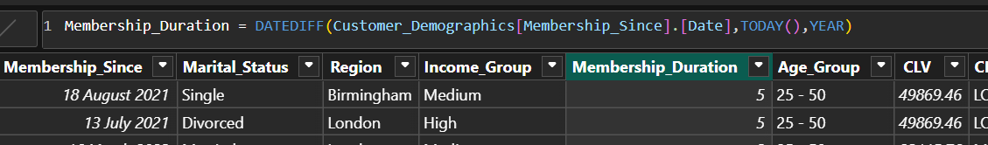

Transaction Year
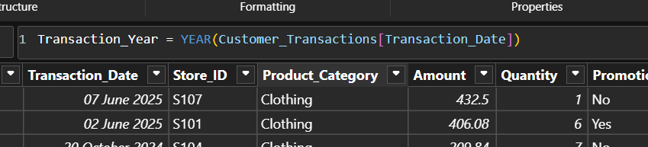

Transaction Month
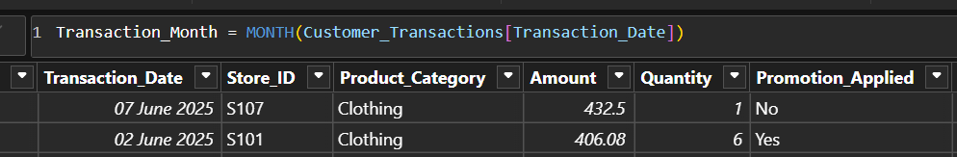

3.Created basic model view.
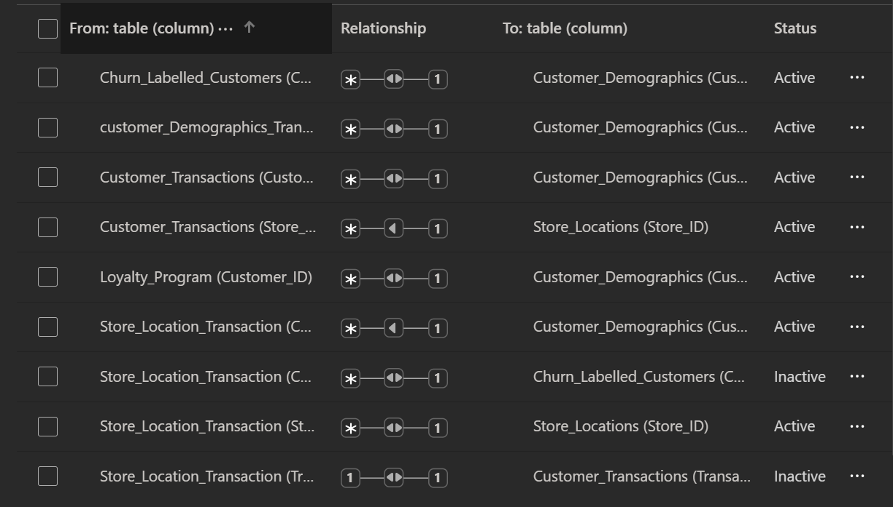

Task 2 – Churn and Retention Metrics
Goal: Identify churn trends across segments

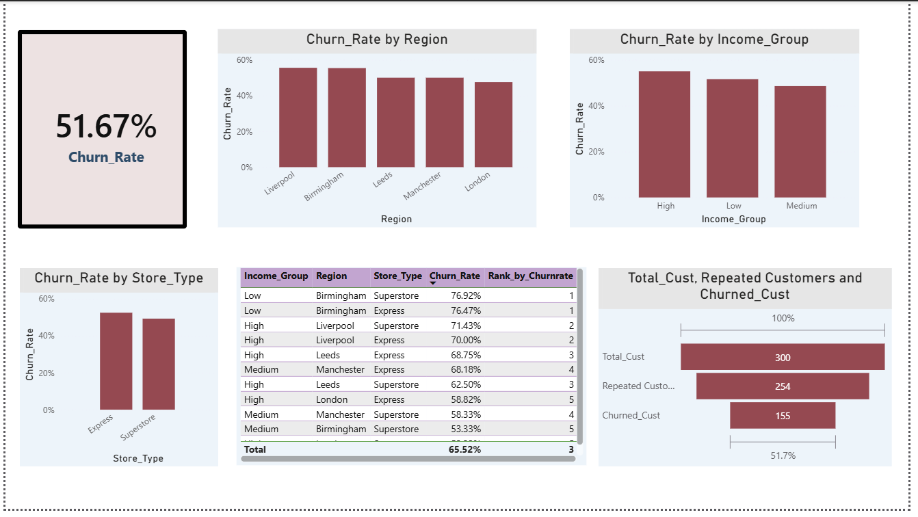
Churn Rate Card:
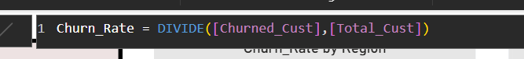
Visualize churn rate by:
1.​Region - done
2.​Income Group - done
3.​Store Type (via store join) - done
4.Identify top 5 segments with highest churn % - done

Create funnel chart: Total Customers → Repeat → Churned – done

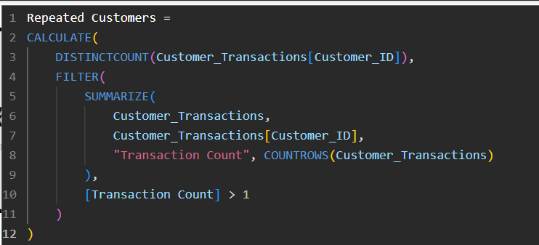

Task 3: Repeat Purchase Analysis
Goal: Understand customer loyalty through repeat behaviour.
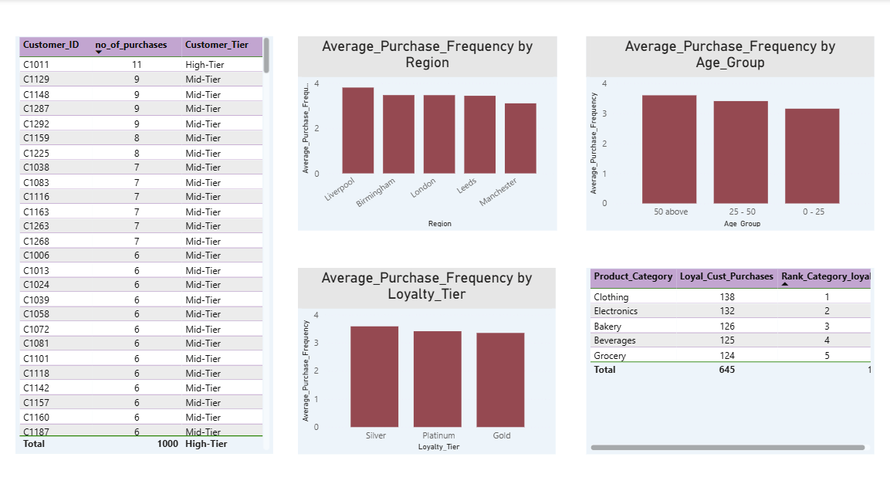 1.​Create a measure:
Low-Tier Customers: (2-4 purchases)
Mid-Tier Customers: (5-10 purchases)
High-Tier Customers: (11+ purchases)

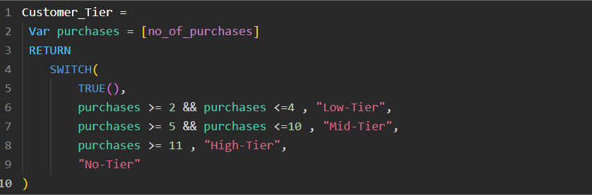
2.​Compare avg. purchase frequency by:
- Region - done
- ​Age Group - done
- ​Loyalty Tier – done

3.Identify product categories most frequently bought by loyal customers.
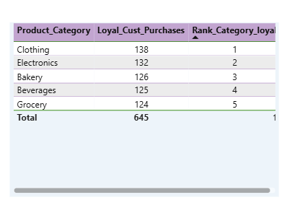
Task 4: Promotion & Loyalty Impact
Goal: Evaluate how promotions and loyalty tier affect retention
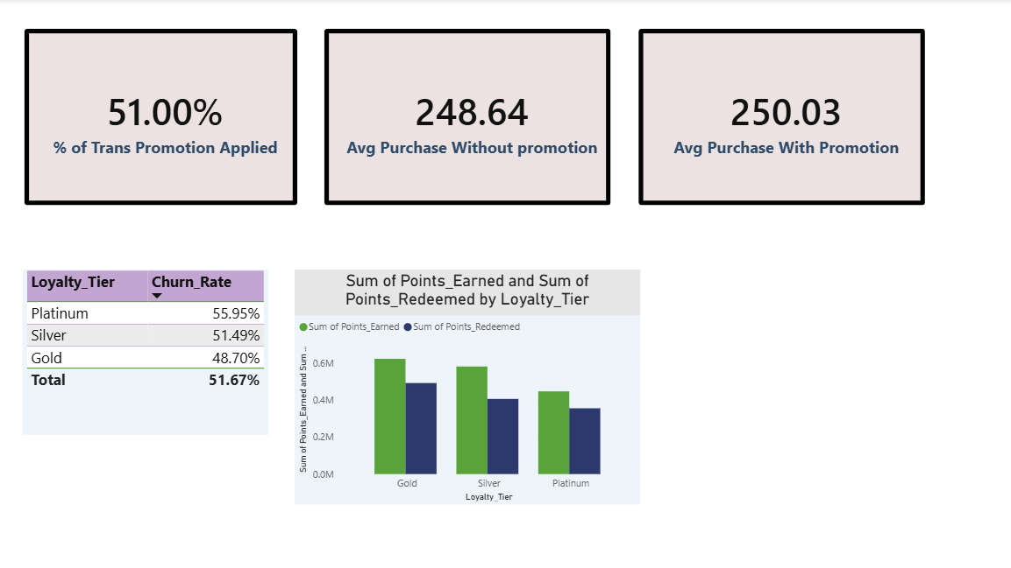
1.​Create Measure:
- ​% of transactions where promotion was applied

- ​Avg. purchase amount with vs without promotion

2.Compare churn rate across loyalty tiers.
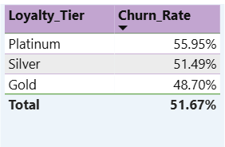
3.Show Points Earned vs Redeemed by Tier using clustered column chart.

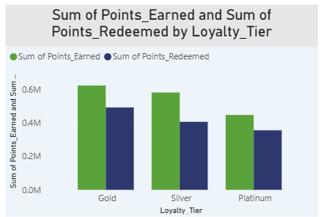

4.Recommend how to improve redemption and retention.

Inferences:
- From the data, we could infer that churn rate for platinum customers is more. Hence, the most premium platinum customers are leaving more.
- Difference between with promotion and without promotions are very small. Hence, promotions are not meaningfully increase the purchase value.
- Points earned is more than the points redeemed. Hence, the customers are not actively participating or they are not getting visible benefits through the points.
Recommendations to improve redemption:
- Allow more flexible redemption options like
- Offers for points
- Bill discount like Rs 50/- off
- Small gift rewards
- Lower the minimum threshold of redemption
- Make minimum redemption from 2000 to 1000. Otherwise, points will accumulate without redeeming, but customer churn increases.
- Give seasonal, festive offers based on points earned.
- Increase visibility of points.
- Points remainder on IKEA App.
- Remainder through Emails and SMS.
- Give attractive premium rewards to platinum users as the churn rate is high among the community.
- Add auto redemption of points to coupons.
Recommendations to improve retention:
- Arrange easy upgradation to premium users campaign.
- Give platinum users more priority, more offers, more discounts and premium product giveaways.
- Dedicated support
- Priority checks
- Exclusive promotions
- Personalized rewards
- Build personal promotion strategy like higher discount for inactive customers , free delivery.
- Predict churn early and give special offers.
- Improve customer experience and assembling assist.

Task 5: Store Performance vs Retention
Goal: Link store characteristics to retention outcomes.
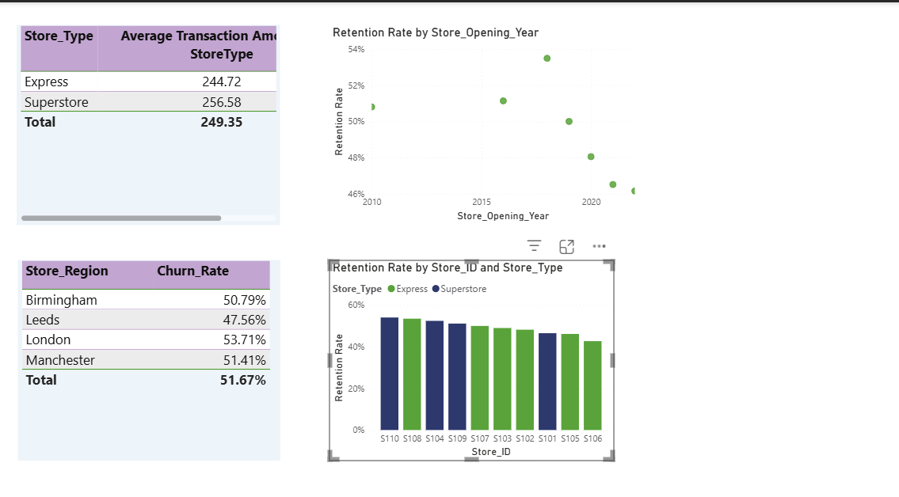

1.Merge Store_ID from transactions with Store_Locations.

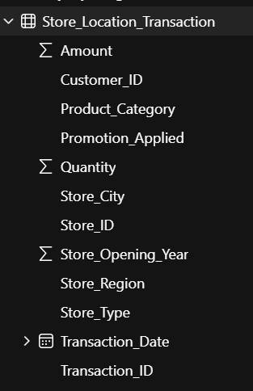

2.Visualize:
- Avg. transaction amount by store type - done

- ​Churn rate by store region - done
- Correlation between store opening year and retention – done


3.Suggest where to run store-specific campaigns:
1. Based on store type, average transaction amount is lesser for Express stores and in numbers, we have more number of Express stores than Superstores.
2. Express stores have lower spend and lower retention, hence, lower quality customers. They need more loyalty push , personalised offers and in-store engagement campaigns.
3. In the bar chart- retention rate by store id, the lowest performers needs campaign engagements. Ie, S106,S105,S101,S102,S103 needs store-specific campaigns.
4. Based on the region level, London and Manchester are having the highest churn rates, Hence, they need to run retention campaigns. We can find location-wise & Climate-wise requirements and can give discount campaigns based on that.
5. Based on store opening date, newer stores needs on boarding campaigns.
6.Hence, High risk region , High risk stores needs more campaigns & newer stores needs onboarding campaigns.

Task 6: Customer Value (CLV) Analysis:
Goal: Identify and prioritize high-value customers.

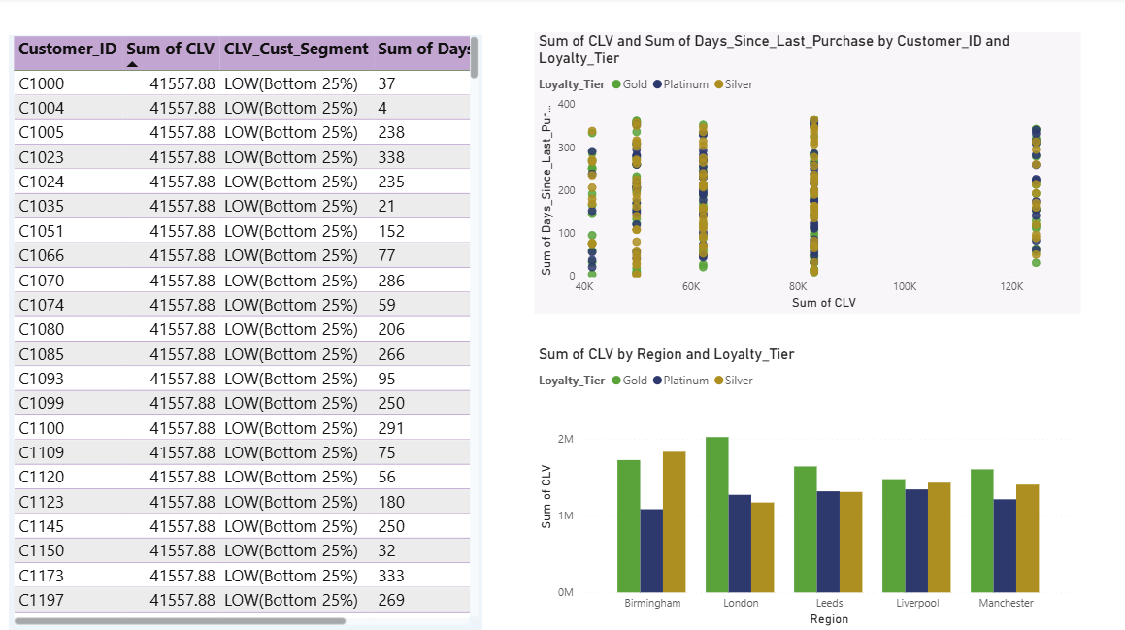

- Calculate CLV = Total Amount Spent / Membership Duration (in years)
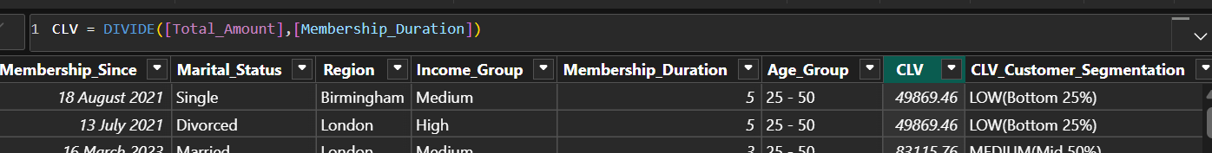

- Segment customers into:
- ​Low (Bottom 25%)
- ​Medium (Mid 50%)
- High (Top 25%)

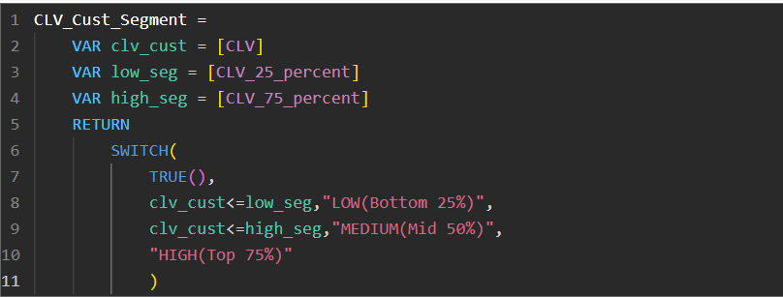

3.Visualize:
- CLV vs Days Since Last Purchase - done
- ​CLV by Loyalty Tier and Region - done

Identified high valued customers:

Task 7: Final Dashboard and Executive summary
Goal: Communicate insights for business action
- ​Create a multi-page Power BI report:
- ​Page 1: Overview KPIs (Churn, CLV, Repeat Rate)

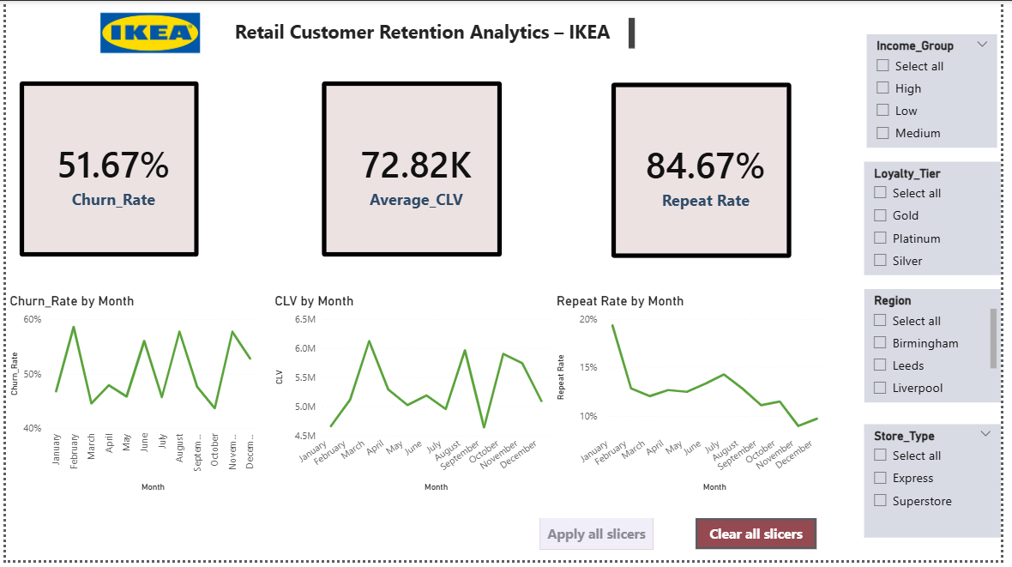

- Page 2: Loyalty & Promotion Impact

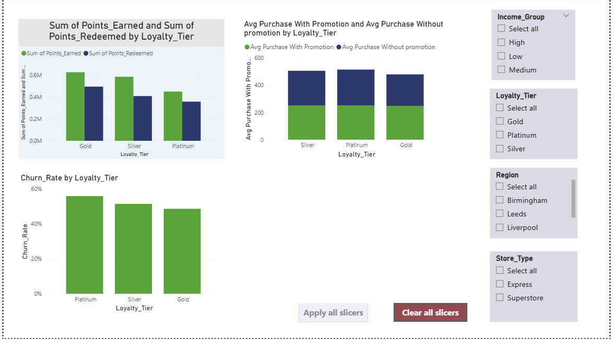

- ​Page 3: Store and Region Insights

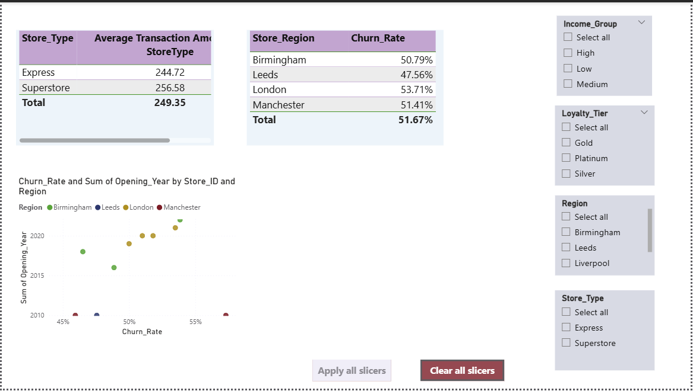
- ​Page 4: Customer Segmentation (Churned, Repeat, High-Value)

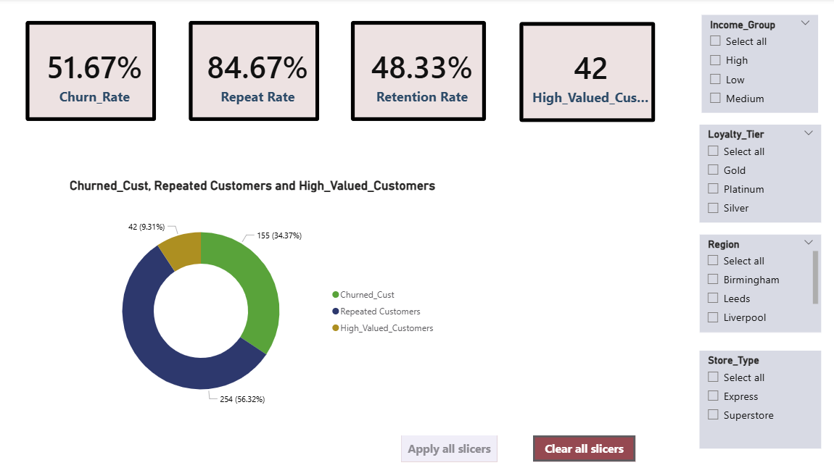

- Create a card or textbox summarizing top 3 recommendations:

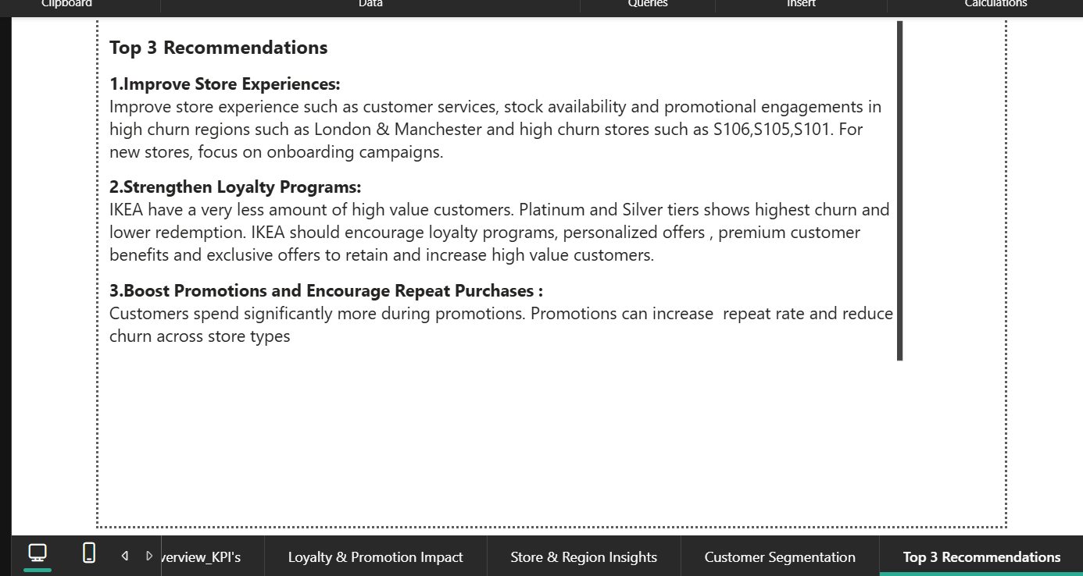
- What should IKEA do to retain more customers?

- Focus on promotions more strategically: Average purchases with promotion is higher across all loyalty tires.
IKEA should announce
1.Seasonal Promotions.
2.Region-specific promotional campaigns.
3.Onboarding campaigns for new stores.
4.Give offers and discounts for dormant customers.
2. More loyalty push for the customers in Express stores: Since the Express store customers are having a lower transaction average,
IKEA should add the below enhancements:
1.Better product quality.
2.Faster & Better customer service.
3.Seasonal & Regional product varieties.
4.In-store pickup benefits.
3.Fix issues in churned regions: London shows 53.71% churn, highest among all regions.
IKEA should focus on retention actions such as:
1.Improve checkout experience.
2.Apply region-based product distributions.
3.Give more offers & discounts.

- Where should they focus next?​
1.Platinum & Silver loyalty tiers: They have high churn rate and they are high spenders.
2.London & Manchester: Highest churned regions – It can improve the retention rate if we focus on them.
3.Promotion-driven marketing based on Region, Loyalty tier and Purchase history: Promotions will increase transaction value.
4.Newly opened stores: Focus on onboarding campaigns, best customer services and store setup.

Video Explanation:
https://www.loom.com/share/95cd887c512d4d6d861030a0ac1f12af

